|  |
| --- |
|  |
| Capstone Project Document |

**Carrier Trading Center**

Report #1 – Project Plan

|  |  |  |
| --- | --- | --- |
| **Carrier Trading Center** | | |
| **Group Members** | Lê Văn Dương | SE03290 |
| Vũ Văn Quyết | SE03344 |
| Đặng Lê Tuấn | SE03807 |
| Trịnh Đình Quyết | SE03159 |
| Lê Gia Hoàng | SE03200 |
| **Supervisor** | Mr. Nguyễn Văn Sang | |
| **Project code** |  | |

**- Hanoi, 01/2017-**

# SIGNATURE PAGE

AUTHOR: Trịnh Đình Quyết 15/01/2017

Team member

REVIEWERS: Lê Văn Dương 20/01/2017

Project manager

APPROVAL: Nguyễn Văn Sang --/--/2017

Supervisor

**Record of change**

*A - Added M - Modified D – Deleted

|  |  |  |  |  |  |
| --- | --- | --- | --- | --- | --- |
| Effective Date | Changed Item | A,M,D | Change Description | Reason for Change | Rev. Number |
| 15/01/2017 | Project plan | A | Create project plan | First version | 1.0 |
|  |  |  |  |  |  |
|  |  |  |  |  |  |
|  |  |  |  |  |  |
|  |  |  |  |  |  |
|  |  |  |  |  |  |
|  |  |  |  |  |  |
|  |  |  |  |  |  |
|  |  |  |  |  |  |
|  |  |  |  |  |  |
|  |  |  |  |  |  |
|  |  |  |  |  |  |
|  |  |  |  |  |  |
|  |  |  |  |  |  |
|  |  |  |  |  |  |
|  |  |  |  |  |  |
|  |  |  |  |  |  |
|  |  |  |  |  |  |
|  |  |  |  |  |  |
|  |  |  |  |  |  |
|  |  |  |  |  |  |
|  |  |  |  |  |  |
|  |  |  |  |  |  |
|  |  |  |  |  |  |

# 

Table of Contents

SIGNATURE PAGE 1

1 Problem Definition 3

1.1 Name of this Capstone Project 3

1.2 Problem Overview 3

1.2.1 The Current System 3

1.2.2 The Proposed System 3

1.2.3 Boundaries of the System 4

1.2.4 Development Environment 4

2 Project Organization 4

2.1 Purpose 4

2.2 Software Process Model 5

2.3 Roles and Responsibilities 5

2.4 Organization Structure 5

2.5 Project Team Member 6

2.6 Tool and Techniques 6

3 Project Management Plan 7

3.1 Tasks 7

3.2 Meeting Minutes 7

3.3 Coding Conventions 8

3.4 Risk Management Plan 8

3.5 Communication Plan 9

# 

# 1 Problem Definition

## Name of this Capstone Project

The official and formal project name is Travel Assistant Mobile Application. The product name is Travel Assistant but it might be different once the project is completed and comes to deployment.

## Problem Overview

### The Current System

There is no current system. The product is building from scratch as a new idea.

### The Proposed System

The main system will be a Website Management.

#### Client User Module

* **Register**: Goods owner and carrier can register an account and login to use some features of CTC.
* **Login/Logout**: Goods owner and carrier login/logout an account to use or exit system CTC.
* **Create a new exchange**: Goods owner can create a new exchange.
* **Auction** : Carrier can auction some goods to transport.
* **Search**: Goods owner and carrier can search auction with types of goods, where to go, destination, receiving time, arrival time, transaction status. System will display all of project relate to keywords.
* **Cancel** : Carrier and goods owner can cancel auction.
* **Profile:**
  + **Change password**: Carrier and goods owner can change password to keep security.
  + **Update profile**: Carrier and goods owner can change or update information.
* **Send report**: Carrier and goods owner can send report to admin.

#### Admin Module

* **Login/Logout**: Admin login/logout an account to use or exit system CTC.
* **Manage goods owner and carrier:**
  + **Search user: Search goods owner and carrier:** Admin can search goods owner and carrier with account name, name of goods owner and carrier, phone number, email address. System will display all of project relate to keywords.
  + **Inactive/active goods owner and carrier**: admin can set goods owner and carrier account to inactive or active.
  + **Delete goods owner and carrier** : admin can delete a goods owner and carrier.
* **Manage auction:** 
  + **Search auction**: Admin can search auction with types of goods, where to go, destination, receiving time, arrival time, transaction status. System will display all of project relate to keywords
* **Send report:** Admin can send report to goods owner and carrier.

### Boundaries of the System

The system under development of this Capstone Project will include:

- The Management Website

- All the process document involved

### Development Environment

Below is the list of hardware and software requirements needed for development environment:

**Hardware requirement:**

- Personal computers for developing with the recommended configuration: 4GB of Ram DDR3, 100GB of hard disk SSD, Processor: 2.4GHz Intel Core i5

- A sever computers for testing with the Recommended configuration: 4GB of Ram DDR3, 100GB of hard disk SSD, Processor: 2.4GHz Intel Core i5

**Software requirements:**

- Operating system: Mac OS X El Capitan, Window 8.1

- Web server: Apache Tomcat

- Framework: .NET Framework 4.0

- IDE: Visual Studio 2010, Xcode 7.1.1

- DBMS: MySQL

- Soured control: Microsoft Project Plan

- Design Graphic: Adobe Photoshop 6, Mockups 3

- Contact tool: Skype, Slack -

- Architecture design: Enterprise Architect 9.3

# Project Organization

## Purpose

This chapter provides an overview of the project plan includes project organization and project management plan.

## Software Process Model

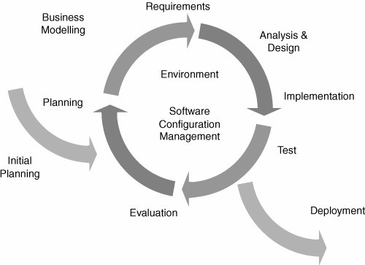

Figure 2‑1: Iterative and Incremental Software Process Model

This figure above describes the Iterative and Incremental Software Process Model that is used by CTC.

The Iterative and Incremental Software Process Model a method of software development that is modeled around a gradual increase in feature additions and a cyclical release and upgrade pattern. In incremental development, different parts of the system are developed at various times or rates are integrated based on their completion. In iterative development, CTC team can revisit parts of the system in order to revise and improve them. Tester’s feedback is consulted to modify the targets for successive deliverables.

## **Roles and Responsibilities**

## Organization Structure

|  |  |
| --- | --- |
| **Role** | **Responsibility** |
| Project Manager | Planning, developing schedules, coordinating communication, generally responsible for keeping the team’s focus on the main goal. |
| Technical Leader | Responsible for choosing and deciding what technologies should be used, as well as for overseeing the work being done by other developers. |
| Quality Assurance Manager | Ensuring the product meets the certain standards of quality from requirements. |
| Test Leader | Responsible for test execution, including test set-up and test run, evaluation of test run and error recovery, defect logging and test results recording. |
| Developer | Involve coding the product and reviewing code of other developers. |
| Designer | Involve designing product’s user interface. |
| Tester | Involve testing the product. |

Table 2‑1: Project Structure

## Project Team Member

|  |  |
| --- | --- |
| **Team Member** | **Role** |
| DuongLV | Project Manager, Developer |
| QuyetVV | Technical Leader, Developer |
| QuyetTD | Tester Leader, QA |
| HoangLG | Developer, Designer |
| TuanDL | Designer, Tester, Developer |

Table 2‑2: Project Team Member

## Tool and Techniques

|  |  |
| --- | --- |
| **Programming languages** | JavaScript, Java, Html |
| **Framework** | Java Server Face, Hibernate |
| **Software architecture** | Spring Framework |
| **Version control** | TortoiseGit |
| **IDEs/Editors** | Eclipse |
| **UML tools** | Astah Professional 7.0 |
| **Web server** | Apache Tomcat 7 |
| **DBMS** | MySQL |
| **Deployment server** | Apache Tomcat 7 |
| **Project management tool** | Microsoft Project 2010 |
| **Process model** | Iterative and incremental Software Process Model |
| **Development process** | Test-driven development |

Table 2‑3: Project Team Member

# Project Management Plan

## Tasks

Refers to “CTC_Project_Schedule_v1.0_EN” file.

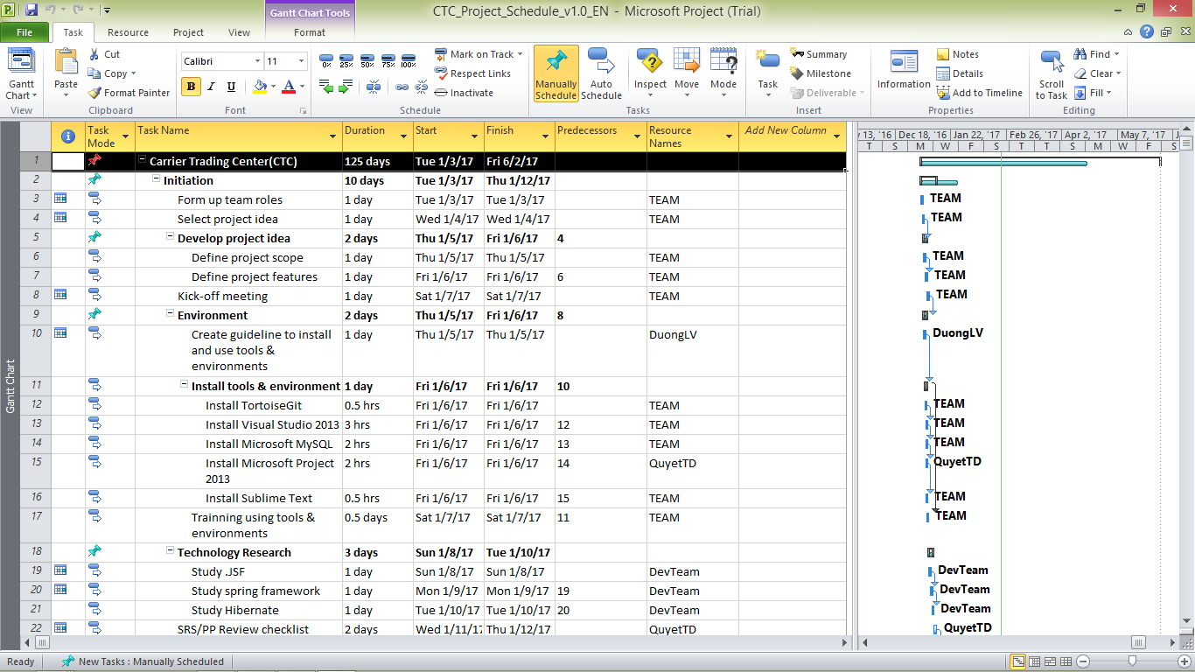

Figure 2‑2: CTC Project Management file

## Meeting Minutes

All meeting minutes will be written following this template:

| ***Meeting/Project Name:*** | *CTC* | | | |
| --- | --- | --- | --- | --- |
| ***Date of Meeting:*** |  | ***Time: (Type)*** | *hours (Face-to-face)* | |
| ***Meeting Called by:*** | *QuyetVV* | ***Location:*** | *FPT University‘s Library* | |
| ***Note Taker:*** | *QuyetTD* | ***Time Keeper:*** | *DuongLV* | |
| 1. Meeting Objective | | | | |
| * Choose names, ideas for project | | | | |
| 2. Attendance | | | | |
| ***Name*** | ***Roles*** | ***E-mail*** | | ***Phone*** |
| Lê Văn Dương | Project Manager | [DuongLVSE03190@fpt.edu.vn](mailto:DuongLVSE03190@fpt.edu.vn) | | 0166-977-5349 |
| Lê Gia Hoàng | Developer | [HoangLGSE03200@fpt.edu.vn](mailto:HoangLGSE03200@fpt.edu.vn) | | 0165-901-2428 |
| Đặng Lê Tuấn | Designer | [TuanDLSE03807@fpt.edu.vn](mailto:TuanDLSE03807@fpt.edu.vn) | | 0968-095-029 |
| Vũ Văn Quyết | Technical Leader | [QuyetVVSE03344@fpt.edu.vn](mailto:QuyetVVSE03344@fpt.edu.vn) | | 0972-381-151 |
| Trịnh Đình Quyết | Test Leader/QA | [QuyetTDSE03159@fpt.edu.vn](mailto:QuyetTDSE03159@fpt.edu.vn) | | 0964-657-385 |
| 3. Content | | | | |
|  | | | | |
| 4. Note | | | | |
|  | | | | |

Table 2‑4: Meeting Minutes Template

## Coding Conventions

Reference to CTC_Coding_Convention_Oracle_EN

## Risk Management Plan

|  |  |  |  |  |
| --- | --- | --- | --- | --- |
| **No** | **Description** | **Avoidance plan** | **Contigency plan** | **Status** |
| R1 | **Illness or absence of team members** | Member has to notice to the team about absence period and the plan of how to keep up with the work process. | Ensure that the absence of a member will not affect others and always have plans to deal with this problem. | Closed |
| R2 | **Business problem** | Any ideas are welcome but members have to discuss with others and always focus on the reality and possibility. | Make sure the business logic of any ideas is carefully analyzed. | Closed |
| R3 | **Change management overload** | A large number of change requests dramatically raises the complexity of the project and distracts key resources. | If there is a “must be changed” requirement, all team members must join the meeting to decide whether it should be implemented or not. | Closed |
| R4 | **Project team misunderstand requirements** | When the project team a gap misinterprets requirements develops between expectations, requirements and work packages. | Make sure any miscommunication has to be resolved. | Closed |
| R5 | **New technology** | Choosing technology based on member’s qualification. All team members must nurture by self-study. | When someone chooses a new technology, he/she has to explain to all team members about the decision. | Closed |

Table 2‑5: Risk Management

## Communication Plan

*Weekly meeting schedule:* We use Iterative and Incremental Process Model, then we divide the system into two sub-systems (CTC services and CTC Front-end), each sub-system is divided into a bunch of small tasks. Each task is recorded to Trello then estimated depending on difficulty and the amount of work by the whole team, after that the Team Leader will assign the task to team members and depending on difficulty, the Technical Leader will assign deadlines for each task. We will have a meeting every Monday to inform to all team about what each member finished last week, the status (fast, on time or slow), the issues met and how to solve them. If any member raises any issue, the whole team will help to find out a solution together. After that, the team will define detailed stories for next week tasks and estimate how long it takes to finish them.

*Daily discussing schedule*: Each sub-system has one development team with different schedule. Whenstarting work-day, each team will have a stand-up meeting to inform to others: “What did I do yesterday?”, “What will I do today?” and “Are there any impediments in my ways?”. By focusing on what each person accomplished yesterday and will accomplish today, the team gains an excellent understanding of what work has been done and what work remains.

*Unscheduled meeting*: If someone has an important problem that he wants to solve immediately, we will have a meeting for discussion, usually via some online channel: Facebook, Skype, or Phone.

*Communication channel*: Our main communication channels are sky. On the other hand, we used face-to-face meeting, Email, Messenger. However, we sometimes make a phone call or instant message if someone has a problem.